*** CALL FOR ENTRIES ***
European Literature Night
New Literary Voices, Translation Pitch

---------------------------------------------------------------------------------------------------------------------------------------------
As a part of the 2015 European Literature Night (ELN) series*, we are looking for translators who would like to pitch an exciting work with international potential by a European author for our new event, The ELN Translation Pitch. The ELN Translation Pitch is open to all translators living in the UK, or in mainland Europe, who have an author whose work they are proposing to translate into English and develop for publication.

The six best proposals will be shortlisted by a panel of judges and the selected translators will compete for the Best Pitch by presenting their project live to a jury and audience, who will vote to determine the winner. The winning translator will be offered support and promotion from Free Word and English PEN. The winning translation will be subsidized by English PEN and published on the PEN website with an accompanying interview on the Free Word site. PEN will also commission a professional reader’s report to accompany the sample translation, so that it can be presented to UK publishers.

The aim of The ELN Translation Pitch is to support and promote the work of EU writers who have not yet had a complete work published in English, while providing an opportunity for translators to actively champion the work of their favourite writers in front of UK publishers and literary agents.

Please submit your pitch by completing the form and sending it to Renata Clark, clarkova@czechcentre.org.uk, by Friday 16 January 2015.

Terms and conditions for the nomination & selection process:
- Translators must be resident in the UK or mainland Europe
- The proposed European writer must not yet have had a complete work published in English (extracts published in anthologies and magazines are acceptable)
- The proposed extract should not be published prior to the ELN Translation Pitch event
- The translator must check that the English translations rights are available and seek permission from the rights holder to pitch the book at this event
- The original publication date of the proposed work must be later than 31 December 1989
- A sample translation of a maximum of 2000 words in Word format must be submitted together with an application form
- Nominations will be considered by a panel of judges who will select the finalists for the pitch based on literary quality and strength of the project. Submissions from languages that are translated and published less often are strongly encouraged.
- The six selected projects will be presented by their translators at a live event on Thursday 4 June 2015 at the Free Word Centre. Each pitch will include the reading of an extract by a professional actor.

Contacts
For queries about ELN or the nominations, contact Renata Clark at clarkova@czechcentre.org.uk.
ELN is a EUNIC London project coordinated by the Czech Centre, supported by the Representation of the European Commission in London and carried out in partnership with the British Library and Speaking Volumes Live Literature Productions.

The ELN translation pitch is organized by the Czech Centre London in partnership with English PEN, Free Word, Translators Association and the Emerging Translators Network.
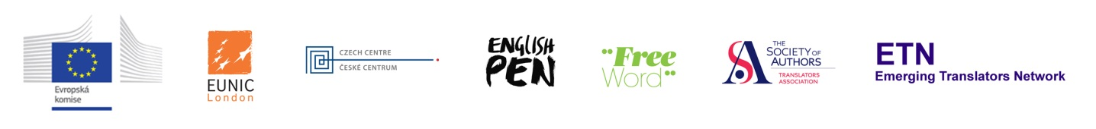-------------------------------------------------------------------------------------------------------------------------------------------------------------------------------------------------------------------------* European Literature Night (ELN) is the annual literary showcase bringing the best of the continent’s authors to the UK.. Held in May each year, ELN in London is part of a number of simultaneous events across European capitals and major cities in celebration of European literature. Now moving into its seventh year, ELN 2015 will be a series of events, including four events at the British Library and the Translation Pitch at the Free Word Centre.

New Literary Voices
The ELN Translation Pitch

Application form

Author:

Original book title:

Translated book title:

Original language:

Publisher & Publication Date:

Number of pages: |  | Genre (e.g. literary fiction/thriller/young adult):

Rights available: UK |  | World English

Name of translator/pitcher:
Translator’s resume: (maximum of 200 words)

Email: |  | Phone Number:

Brief proposal (why this book should be published in English, maximum of 200 words)

Information about the author (previous books, sales history, prizes, other translations, films based on the work, quotes from reviews etc.)

Synopsis (maximum of 200words) (what the book is about, what material it covers, main argument etc)

Sample translation: Attachment in word format of maximum 2000 words

Declaration: There is currently no signed contract for this book to be published in English translation and the translation is yet to be commissioned. If the book is selected for the pitching forum I ……………………..( print name) agree to pitch the book to the jury and audience at the ELN Translation Pitch event.

